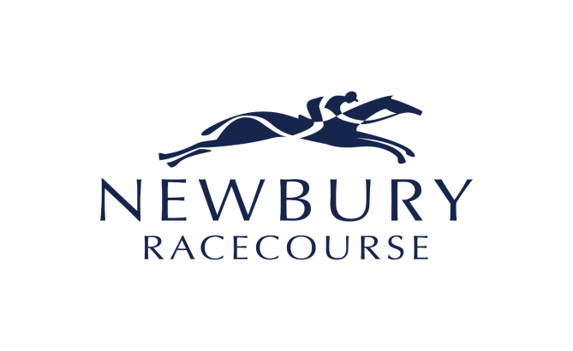

15 September 2021
NEWBURY RACECOURSE PLC
(the “Racecourse” or the “Company”)

Holding(s) in Company

The Company has been notified that Mr Tim Syder holds 220,950 Ordinary shares of 10p each in the Company, representing 6.6 per cent of the Company’s issued share capital.

For further information please contact:
Newbury Racecourse plc Tel: 01635 40015
Julian Thick, Chief Executive
Harriet Collins, Marcomms & Sponsorship Director
Allenby Capital Limited Tel: 0203 328 5656
Nick Naylor/Liz Kirchner (Corporate Finance)
Hudson Sandler Tel: 0207 796 4133
Charlie Jack

